Field | Details
Bug ID | BUG_LOGIN_001
Title | Login validation does not indicate that the password is required when both fields are empty
Module | Login
Environment | Saucedemo/Microsoft Edge/Windows 11/desktop
Status | New

Steps to Reproduce
- Open the SauceDemo login page
- Leave the Username field empty
- Leave the Password field empty
- Click the login button
- Observe the validation message displayed

Expected Result
When both fields are empty, the application should clearly inform the user that both Username and Password are required , or provide clear validation for each missing field.

Actual Result
The application displays: “Epic sadface: Username is required”
Only the username field is identified as missing, even though the password field is also empty.

Evidence
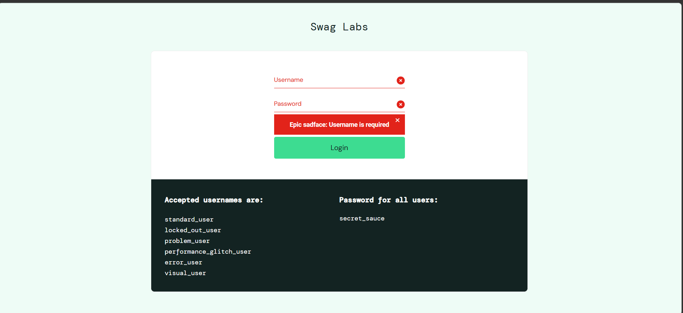

Severity : Medium
The issue does not prevent the user from eventually logging in, but the validation feedback is incomplete and may cause confusion.

Priority: Medium
The issue affects the clarity of the login experience but does not completely prevent the users from correcting their input.

Field | Details
Bug ID | BUG_LOGOUT_001
Title | User gets logged out directly without confirmation message
Module | Logout
Environment | Saucedemo/Microsoft Edge/Windows 11/desktop
Status | New

Steps to Reproduce
- Open the SauceDemo login page
- Login with valid credentials
- Click on the hamburger menu
- Click on logout button
- Observe how the application works

Expected Result
When the user wants to logout, there should be a confirmation message displaying “Are you sure you want to log out?” before actually logging out

Actual Result
The application just logs out the users directly without confirmation messages.

Evidence

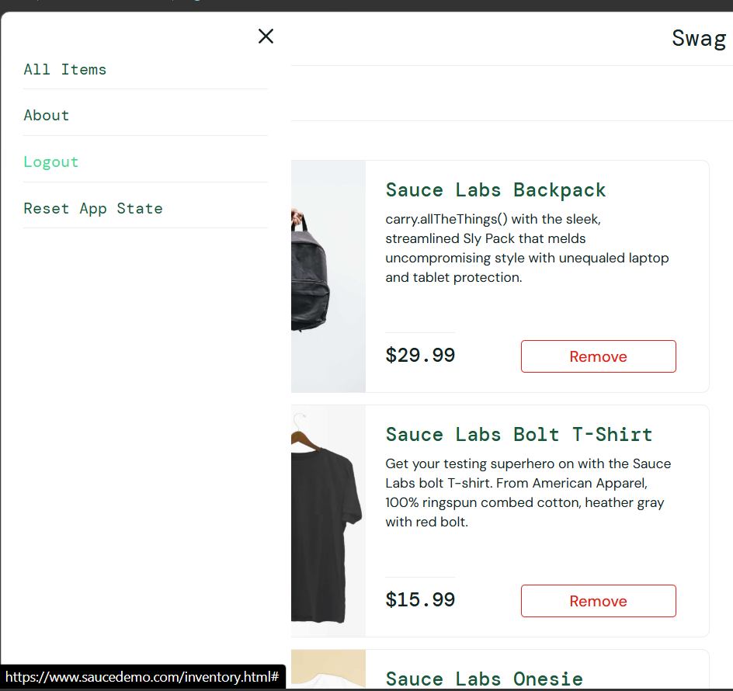
Severity : Minor
The core logout functionality works. The user is actually logged out so there is no functional failure.

Priority: Medium
A logout confirmation improves clarity and user experience. The user may be unsure whether the logout action succeeded, especially when the application redirects them somewhere without explanation.

Field | Details
Bug ID | BUG_PRODUCT_001
Title | The user gets redirected to the login page with an error message when trying to click on the product image to get the product information.
Module | Product
Environment | Saucedemo/Microsoft Edge/Windows 11/desktop
Status | New

Steps to Reproduce
- Open the SauceDemo login page
- Login with valid credentials
- Leave the application as it is for about 10 minutes
- Click on the product images
- Observe the result

Expected Result
When the user clicks on any product image even after leaving the application as it is for about 10 minutes, the user should get redirected to the product details page.

Actual Result
The application displays: “Epic sadface: You can only access '/inventory-item.html' when you are logged in” on the login page instead.

Evidence
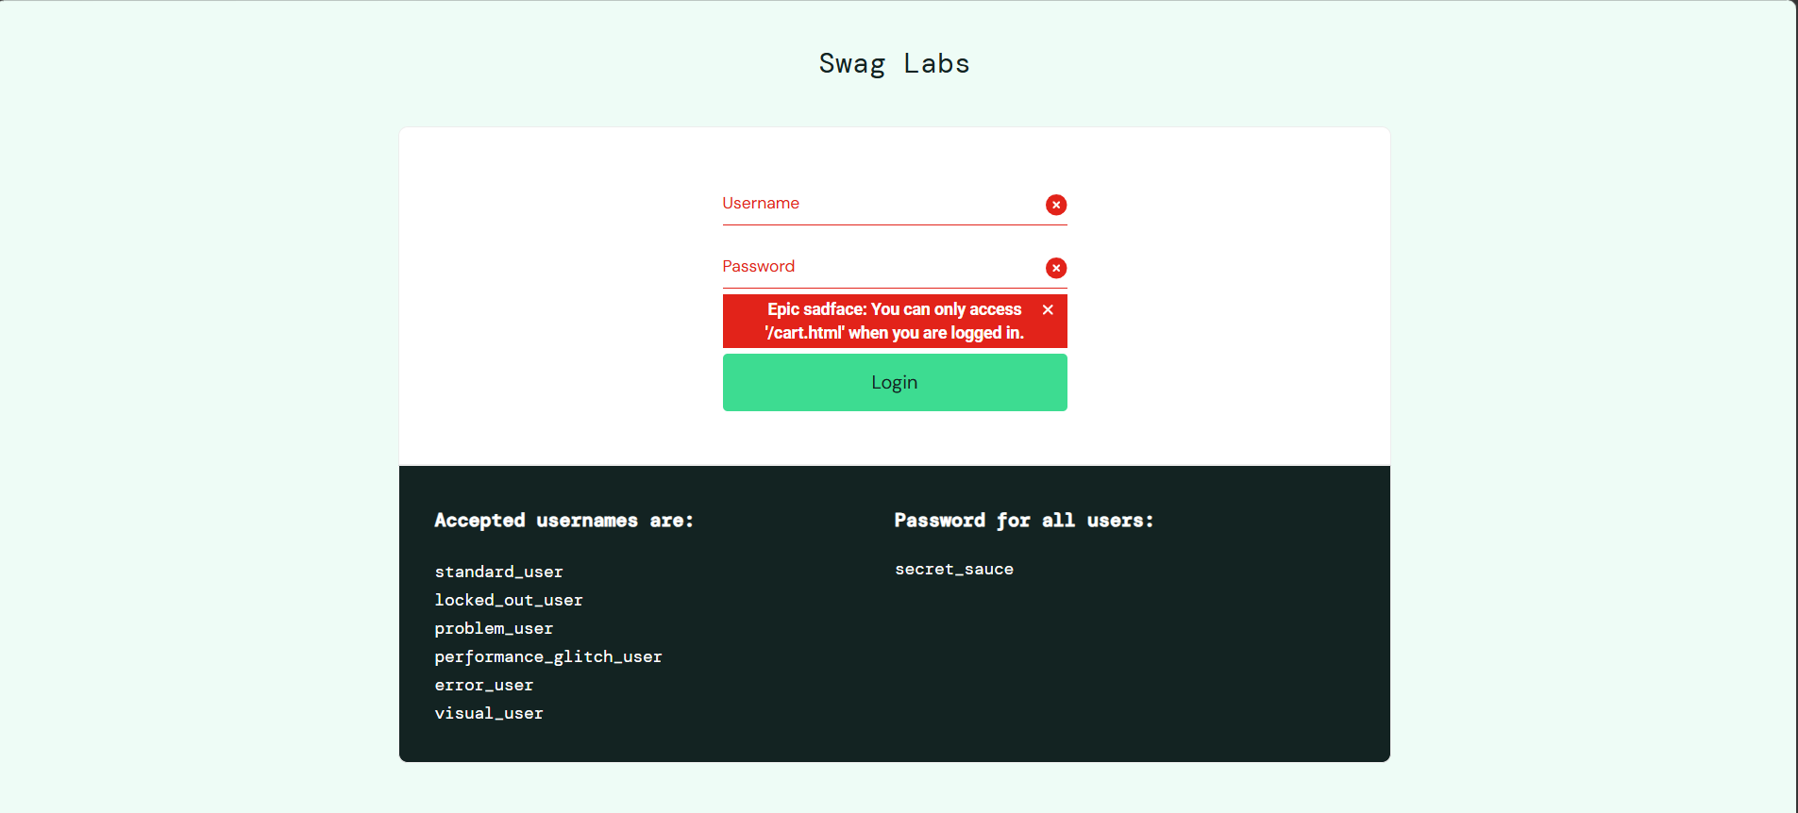

Severity : Critical
The issue prevents the user from getting the details/information about the products. It will also affect the user experience as the user will get redirected to the login page with an error message.

Priority: High
The issue affects the exploring experience of the user as the application is showing a crashing behaviour.

Field | Details
Bug ID | BUG_CHECKOUT_001
Title | The user can proceed to checkout even after entering an invalid zip/postal code.
Module | Checkout
Environment | Saucedemo/Microsoft Edge/Windows 11/desktop
Status | New

Steps to Reproduce
- Open the SauceDemo login page
- Login with valid credentials
- Click “Add to cart” button
- Go to the cart page
- Click on “Checkout” button
- Enter “Sujala” on first name, “Adhikari” on last name and “446000” (Wrong) code on zip/postal code
- Click on the “Continue” button
- Observe the result

Expected Result
When the user proceeds the checkout with an invalid zip/postal code the user should get an error message saying “Please enter 5 digits postal code”.

Actual Result
The application redirects the user to the checkout overview page with an invalid zip/postal code.

Evidence
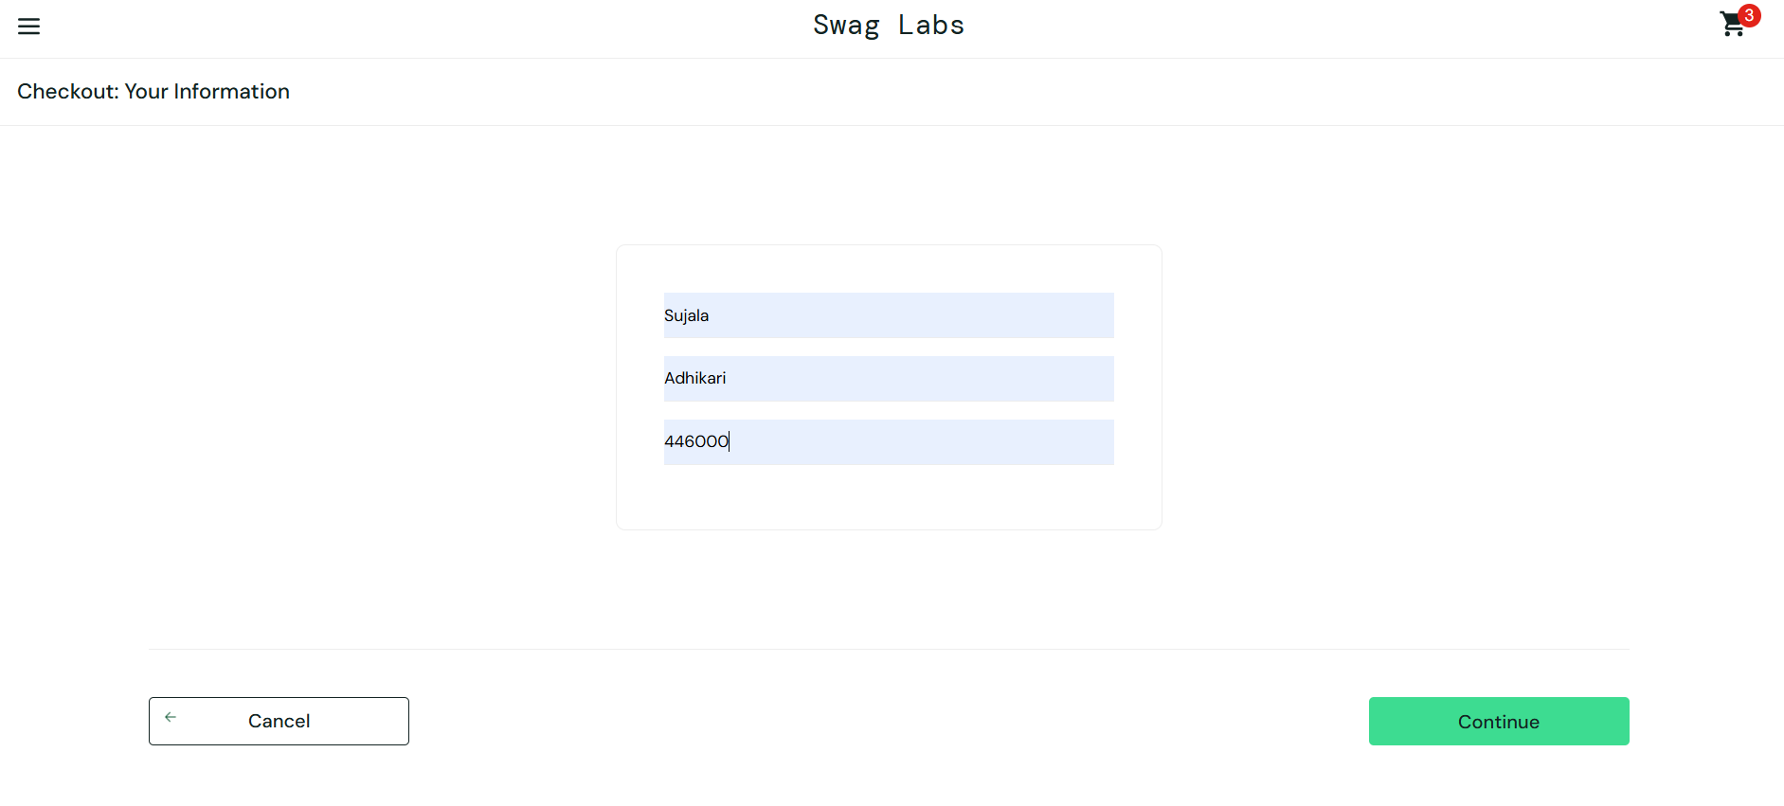

Severity : Medium
The user can still proceed with the checkout process but the invalid input is being accepted by the application.

Priority: High
The issue should get fixed but it doesn’t block the entire checkout process.

